Title: Install Kali Linux Setup Guide
Objective: Install Kali Linux on system
Minimum System Requirements:
- Processor: 64-bit Intel Core i3/i5/i7 or AMD E1 equivalent.
- RAM: 2 GB (4–8 GB recommended for smoother operation).
- Storage: 20 GB HDD or SSD space (Free space).
Steps:
Step 1: Download kali Linux ISO File
- Go to official website: https://www.kali.org/get-kali/#kali-virtual-machines
- Download the Pre-Build Image for Virtual Box
Screenshot: 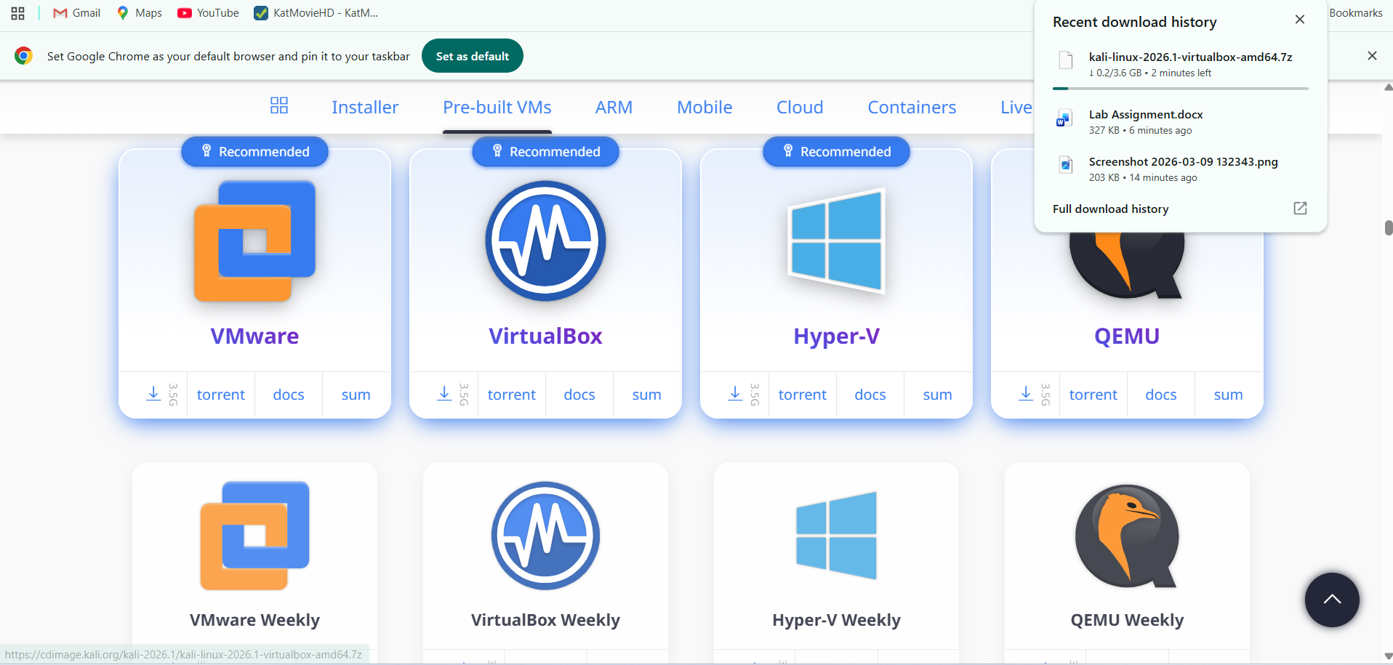
Step 2: Download Virtual Box
- Go to official website: https://www.virtualbox.org/wiki/Downloads
- Download Windows Host
Screenshot: 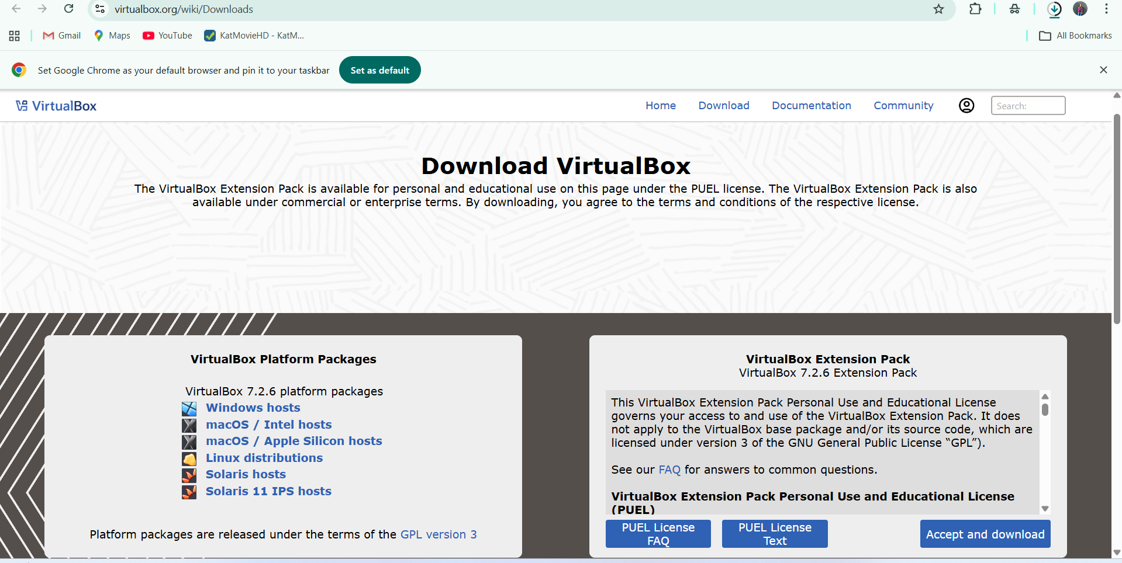
Step 3: Install Virtual Box
- After Download click on executable file and proceed with the guided installation steps (next > next > install)
Screenshot:
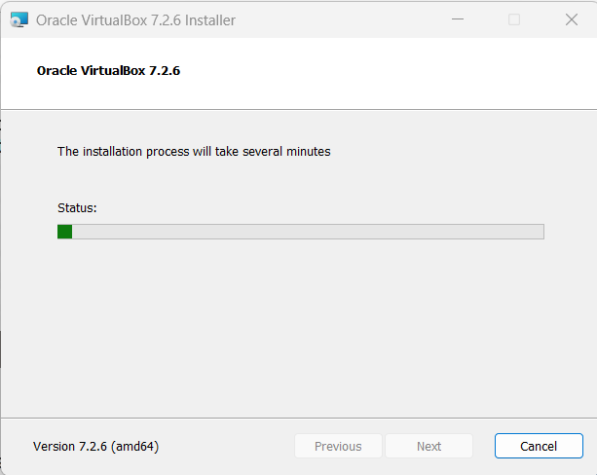

Step 4: Extract the Kali Linux Pre-Built Image
- Navigate to your Downloads folder and locate the downloaded Kali Linux archive (usually a .7z file).
- Right-click the file and extract it using an archiving tool like 7-Zip or WinRAR.
Screenshot:
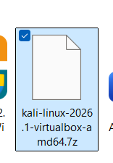
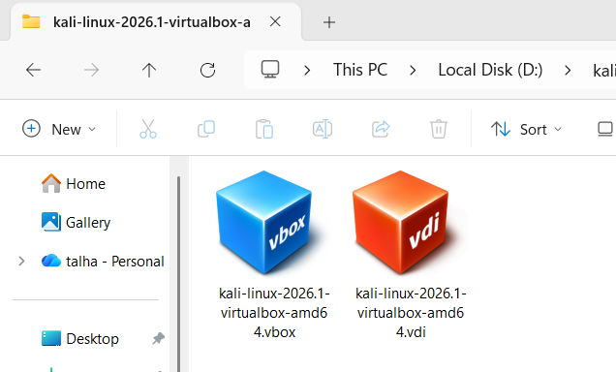

Step 5: Add the Virtual Machine to VirtualBox
- Open the newly installed VirtualBox application.
- Go to the "Machine" menu at the top and click "Add" (or press Ctrl+A).
- Navigate to the extracted Kali Linux folder, select the .vbox file, and click "Open" to import the configuration automatically.

Screenshot:
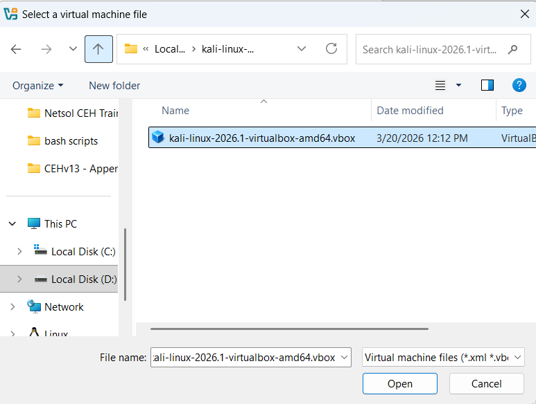

Step 6: Start the Virtual Machine
- Select your new Kali Linux VM from the left-hand menu in the VirtualBox Manager.
- Click the green "Start" arrow icon at the top menu to power on the machine.
Screenshot: 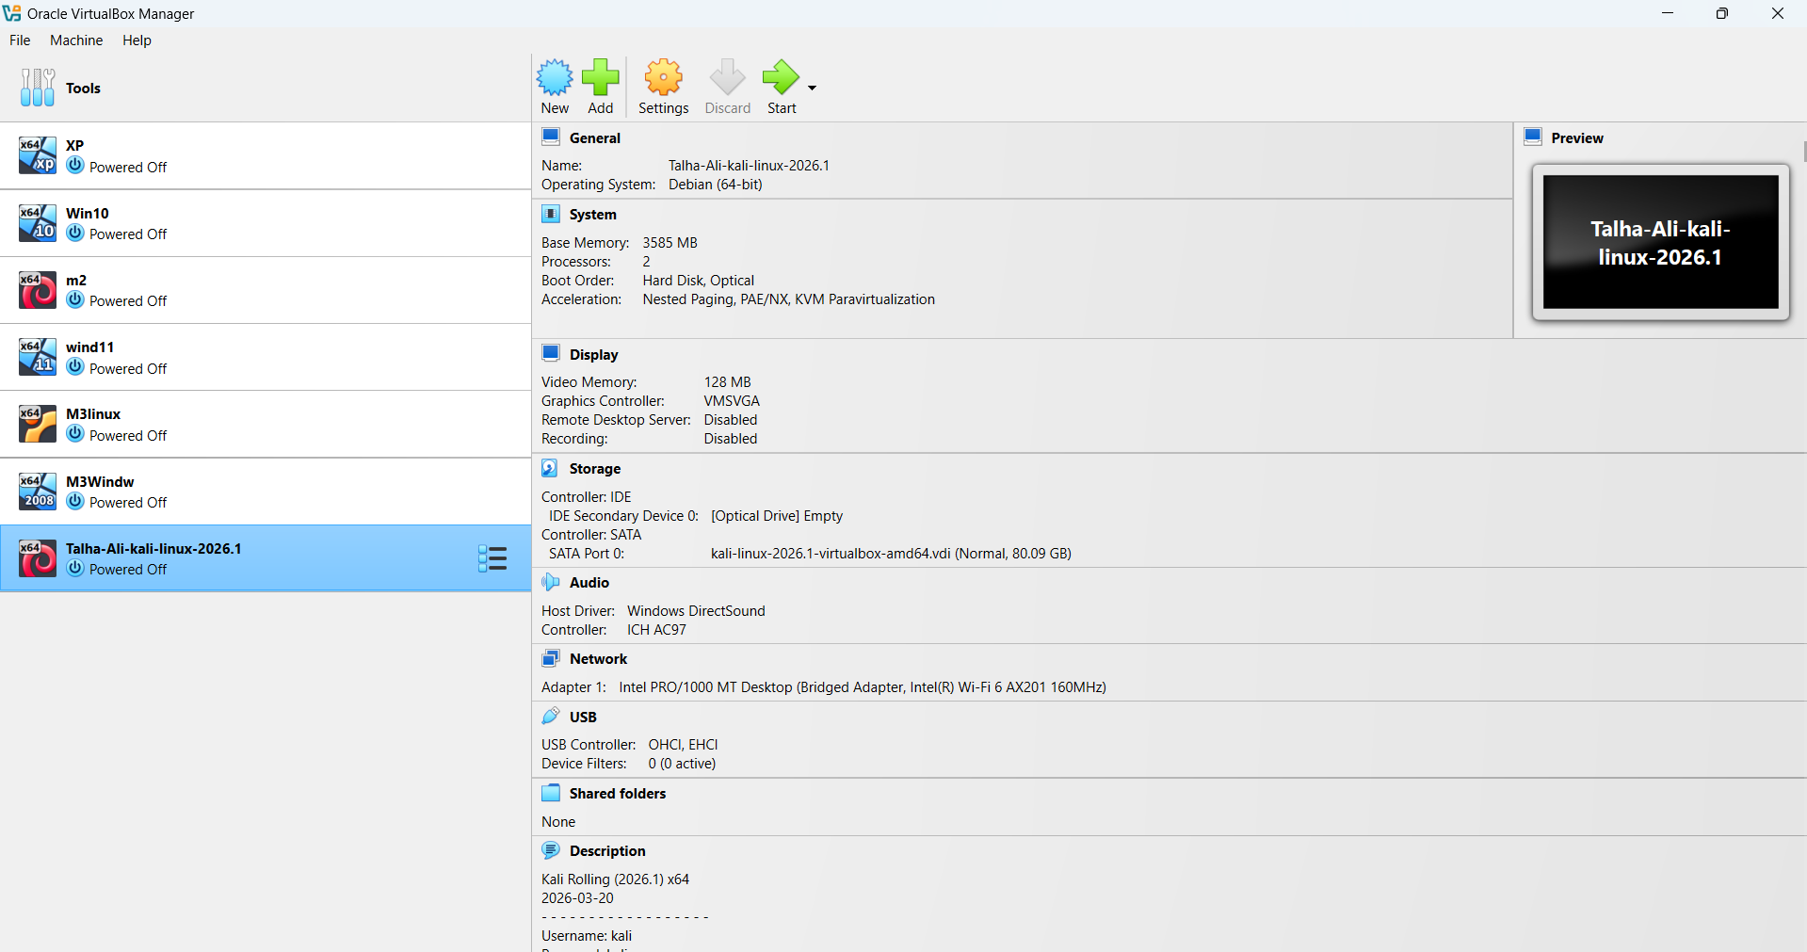
Step 7: Log in to Kali Linux
- Wait for the virtual machine to boot up to the login screen.
- Enter the default credentials to log in:
  - Username: kali
  - Password: kali
Screenshot: 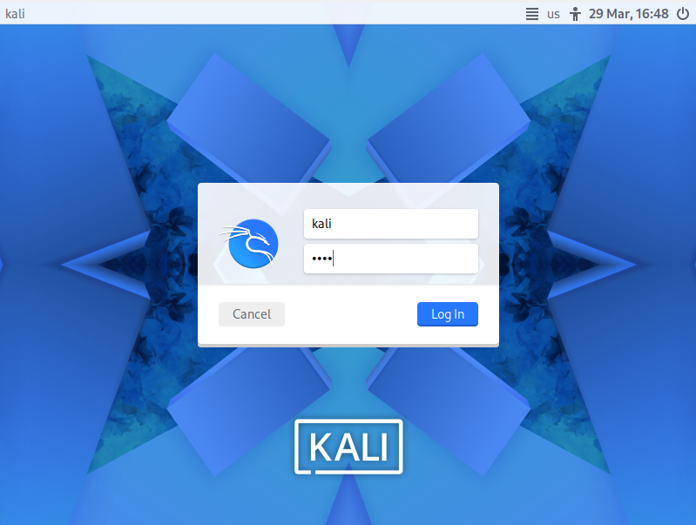
Result: Kali Linux is successfully installed and running on a VirtualBox environment, and the system is ready for lab tasks. 